
Mobit A.Ş.
PRODUCT SPECIFICATION FOR APPROVAL

CUSTOMER ADMIT | RD department
 | CUSTOMER
 | Type of production | 13
 | CustomerˊS PART NO
 | Mode NO | MBT-M10-A
 | Date： | 2013-12-26
 | Edition | 1.0
 | Design By：
 | Auditing：
 | Approve By：

Item | Symbol | Content | Criterion
Current Rating | Ic | Rated charge current | 5A
Current Rating | Id | Rated discharge current | 15A
Over charge Protection | V_{DET1} | Over charge detection voltage | 4.2500±0.050V
Over charge Protection | tV_{DET1} | Over charge detection delay time | 1000 mS Type 2000 mS Max
Over charge Protection | V_{REL1} | Over charge release voltage | 4.100±0.050V
Over discharge protection | V_{DET2} | Over discharge detection voltage | 2.800±0.080V
Over discharge protection | tV_{DET2} | Over discharge detection delay time | 1000 mS Type 2000 mS Max
Over discharge protection | V_{REL2} | Over discharge release voltage | 3.000±0.100V
Over current protection | I_{DP} | Over current detection current | 45A±10A
Over current protection | tV_{DET3} | Over current detection delay time | 10 mS Type 100 mS Max
Short protection |  | Protection release condition | Disconnect the load
Short protection |  | Detection condition | Exterior short circuit
Short protection | tV_{DET4} | Short protection detection delay time | 100 uS Type 600 uS Max
Short protection |  | Protection release condition | Disconnect the load
Interior resistance | R_{DS} | Main loop electrify resistance | R_{DS}≤12mΩ
Current consumption | I_{DD} | Current consume in normal operation | 40μA Type 100μA Max
Over-temperature protection |  | Protection and the protection release conditions | 75 ℃, turned over-temperature protection, 55 ℃ when releasing over-temperature protection
Current balance |  | When the single-cell voltage is equal to 4200V when opening | 45mA Type 80mA Max

█ Pin Description
Description |  |  | Description
P- | Output cable to connect the output load P-negative | B5 |  | 5.node
C- | connect the negative input charger | B6 |  | 6.node
B- | connected batteries negative (High Cuurent) | B7 |  | 7.node
VCC | VCC power supply to the battery protection board | B8 |  | 8.node
B- | Battery negative node | B9 |  | 9.node
B1 | 1.node | B10 |  | 10.node
B2 | 2.node | B11 |  | 12.node
B3 | 3.node | B12 |  | 12.node
B4 | 4.node | B+ |  | Battery positive node
█ Assembly drawing
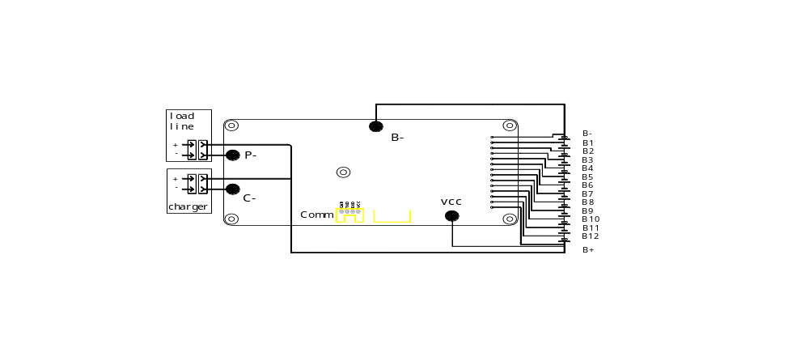


14PIN 2.54mm

PCB
Length: 110mm ± 1 mm Width: 50mm ± 1 mm thickness: 10mm ± 1 mm
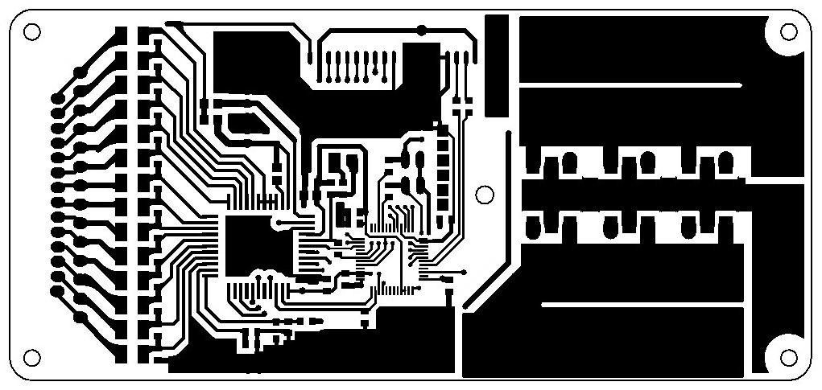
Figure 14: Top Layer

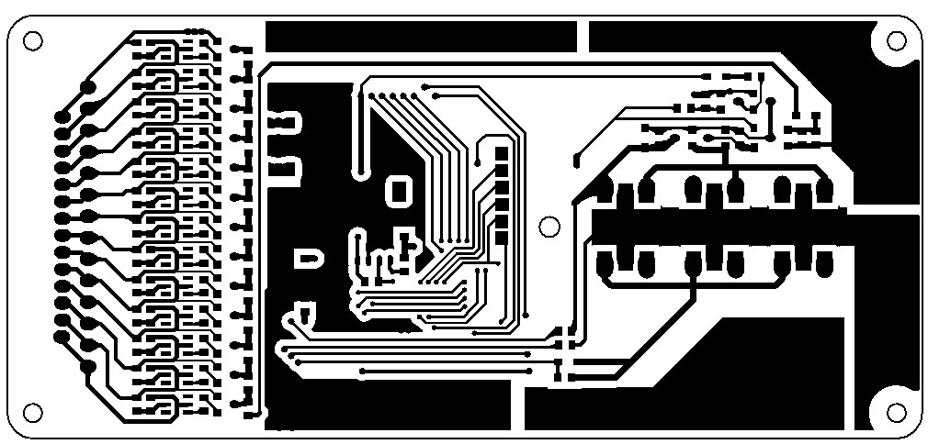
Figure 14: Top Layer
Reliability Testing
Project Performance Standard Test Conditions and Methods
MOS tube test charging overcharge protection when cell voltage reaches 4.200V (± 0.050V), plus the charging voltage to stop charging
Over-discharge protection when tested discharge MOS transistor cell voltage reaches 2.800V (± 0.8V) stop discharge
MOS circuit test tube to protect the external battery, P-and P + (B +) terminal momentary contact.
Vibration test protective plate to protect the board to work on the vibration table, adjust the vibration frequency to 50 Hz, connected load and power supply.
Open circuit protection board protection component testing an important component of the protective plate removed
■ Scope
Parameter Rating unit
Operating temperature -40 ~ 85 ℃
Humidity is less than 85% RH% RH
5 A continuous charging current
Continuous discharge current of 15 A
Storage temperature -40 ~ 125 ℃
Storage humidity is less than 85% RH% RH

